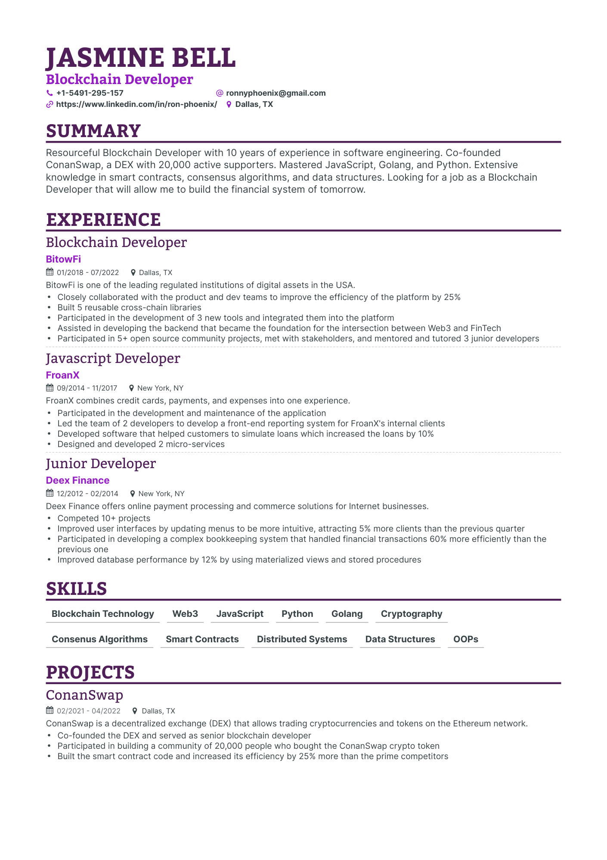
JASMINE BELL
Blockchain Developer
+1-5491-295-157
@ronnyphoenix@gmail.com
https://www.linkedin.com/in/ron-phoenix/ Dallas, TX
SUMMARY
Resourceful Blockchain Developer with 10 years of experience in software engineering. Co-founded ConanSwap, a DEX with 20,000 active supporters. Mastered JavaScript, Golang, and Python. Extensive knowledge in smart contracts, consensus algorithms, and data structures. Looking for a job as a Blockchain Developer that will allow me to build the financial system of tomorrow.
EXPERIENCE
Blockchain Developer
BitowFi
01/2018 07/2022
Dallas, TX
BitowFi is one of the leading regulated institutions of digital assets in the USA.
• Closely collaborated with the product and dev teams to improve the efficiency of the platform by 25% Built 5 reusable cross-chain libraries
Participated in the development of 3 new tools and integrated them into the platform
Assisted in developing the backend that became the foundation for the intersection between Web3 and FinTech Participated in 5+ open source community projects, met with stakeholders, and mentored and tutored 3 junior developers
Javascript Developer
FroanX
09/2014 11/2017
New York, NY
FroanX combines credit cards, payments, and expenses into one experience.
•
•
•
Participated in the development and maintenance of the application
Led the team of 2 developers to develop a front-end reporting system for FroanX's internal clients Developed software that helped customers to simulate loans which increased the loans by 10% Designed and developed 2 micro-services
Junior Developer
Deex Finance
12/2012 02/2014
New York, NY
Deex Finance offers online payment processing and commerce solutions for Internet businesses.
•
.
.
Competed 10+ projects
Improved user interfaces by updating menus to be more intuitive, attracting 5% more clients than the previous quarter Participated in developing a complex bookkeeping system that handled financial transactions 60% more efficiently than the previous one
•
Improved database performance by 12% by using materialized views and stored procedures
SKILLS
Blockchain Technology Web3
JavaScript
Python Golang
Cryptography
Consenus Algorithms
Smart Contracts
Distributed Systems
Data Structures
OOPS
PROJECTS
ConanSwap
02/2021-04/2022
Dallas, TX
ConanSwap is a decentralized exchange (DEX) that allows trading cryptocurrencies and tokens on the Ethereum network. Co-founded the DEX and served as senior blockchain developer
•
•
•
Participated in building a community of 20,000 people who bought the ConanSwap crypto token
Built the smart contract code and increased its efficiency by 25% more than the prime competitors

